Uncomplicated and affordable advice

PROUDLY PRESENT THE
2020
CARDIFF MASTERS Sanctioned by NSWMSA
1st & 2nd February 2020
Entries Close MONDAY 27th January 2020

Try our sponsor The Esplanade Motel for your accommodation.
A quality Motel on the water front at Warners Bay. Walking distance to the cafes and 5 minutes to Cardiff Squash Centre.
Please phone Shannon and Clint to book your accommodation. Ph: 02 4948 9666. Email: info@theesplanademotel.com.au www.theesplanademotel.com.au
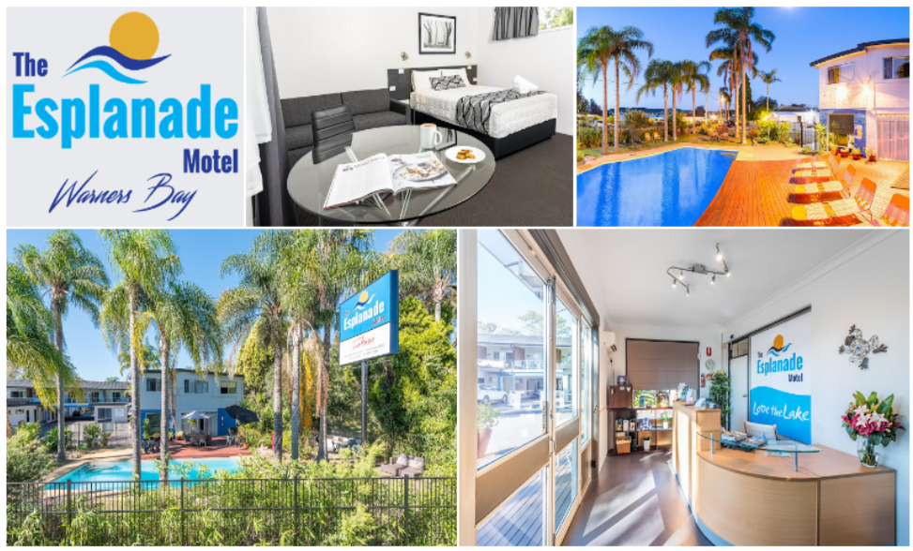

TOURNAMENT CONDITIONS
- This tournament will be a Graded NON Gender event.
- The tournament will be conducted on a Triple Plate or Round Robin System depending on numbers.
- Players may enter one event only and assured of Min 3 Matches
- Scoring will be Par 15 for all Divisions. At 14 all Player must win by 2 points. Best of 5 Games.
- Entry Fee of $40 NSWMSA Member or $50 NON Member and will not be refunded after 27th Jan 2019.
- Late entries may not be accepted and will incur a fee of $5
- All players to report to the Control Desk 30 Minutes prior to their match.
- All players to Mark & Referee the match after their own or as directed. Tournament Referee is Tanya Bailey
- Players to respect their Opponents and Referees.
- Ball to be used for the tournament will be Double Yellow Dot or Single Dot if both players agree to the change.
- Masters Players are not covered by insurance and therefore play at their own risk.
- First Match Times will be available after 12pm Friday 1st Feb 2019 by contacting Cardiff Squash Centre on 0249548966 or Tanya Bailey on 0417130765.
- Post Entry form to Cardiff Squash Centre 52 Ada St Cardiff 2285 or email to sports@atune.com.au or phone 0249548966
- Yummy Hot Food and Snacks, Tea and Coffee will be available over the weekend. We recommend Wests in Munibung Rd Cardiff for meeting on Friday Night and perhaps Warners Bay Pub for Saturday Night Meeting Place
- Final Gradings will be at the discretion of the NSWMSA Registrar

ENTRY FORM
PLEASE NOTE NO ALCOHOL WILL BE SOLD OVER THE WEEKEND. YOU ARE WELCOME TO BYOG
NAME………………………………………………………………………………………………………
ADDRESS………………………………………………………………………………………………….
PHONE Home……………………………………………Mob………………………………………
EMERGENCY CONTACT
NAME………………………………………………..PH………………………………………………..
EMAIL………………………………………………………………………………………………………
MATRIX/GRADE……………………………….CLUB………………………………………………
ENTRY FEE:- (Please Circle) $40 Member of NSWMSA
$50 NON Member NSWMSA
(Membership must be paid to NSWMSA before the tournament if you wish to pay members rates)
Payment to be by one of the following:- (Please Circle)
Credit Card OR Cheque (Made payable to Atune Health Centre) OR Cash
CARD DETAILS:- (Please Circle) VISA MASTERCARD

Number………………/………………/………………/…………….. Exp…………………….
EMAIL ENTRY WITH PAYMENT TO sports@atune.com.au
I enclose my entry fee and agree to abide by the Tournament Conditions and play with the Masters Spirit.

Signature………………………………………………………………………

